**EC ENGR 111L**

**Experiment #4**

**Resonance Circuit**

Name: Ma, Yunhui

UID: 505-179-815

Lab Section: 1E

Date:5/27/2019

**Part#1: Series Resonance Circuit**

**Objectives:**

In the series resonance circuit, calculate the resonant frequency wR and quality factor Q for each component, and compare to the theoretical value. Find the gain and phase graphs under the sinusoidal voltage input.

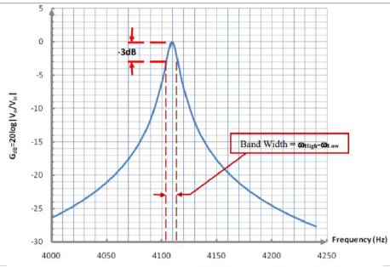**Theory:**

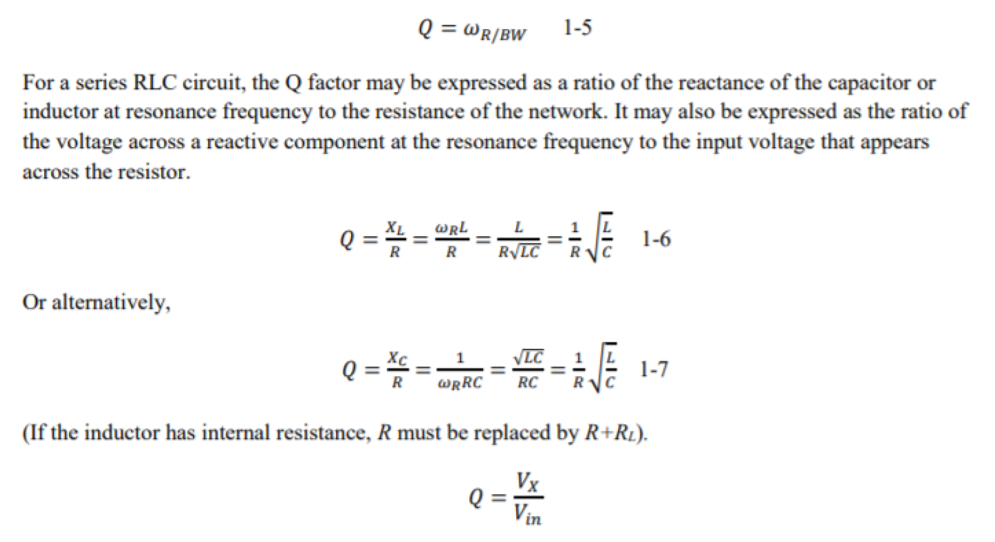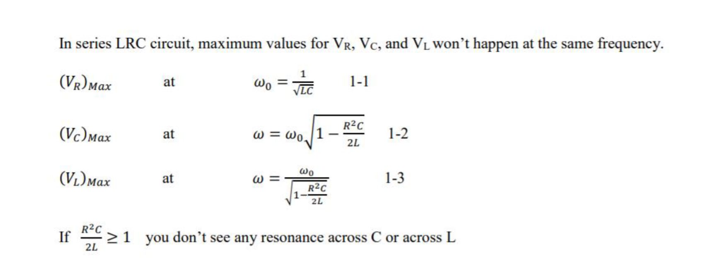

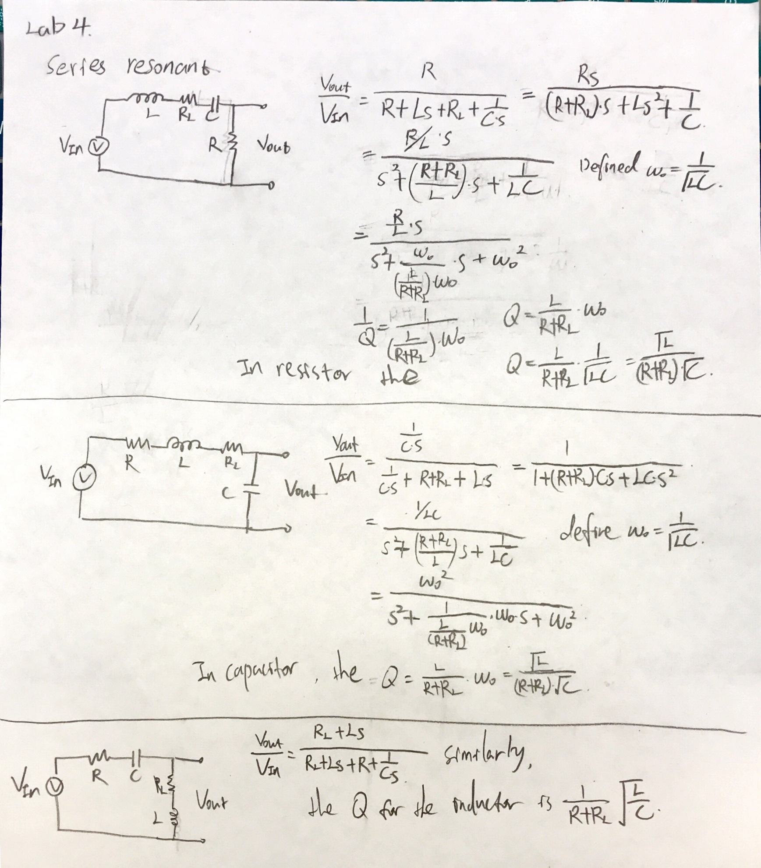The transfer functions for each component.

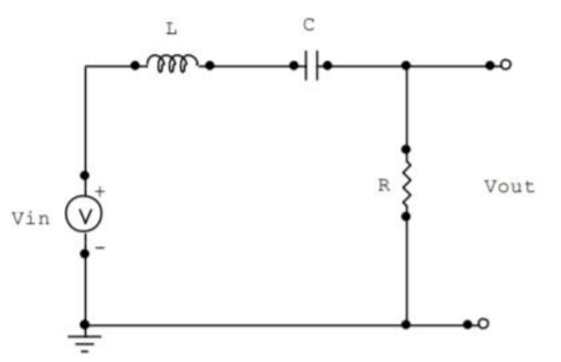**Procedure:**

1. Implement the circuit as above.
2. Using Bode analysis to get the Bode plot for Resistor.
3. Repeat 1 to 3 for inductor and capacitor.
4. Find the resonant frequency when the magnitude bode plot for voltage is maximum. Compare it with experimental value and find the percent error.
5. From the magnitude bode plot, decrease the maximum voltage by 3-dB and find the frequency difference which is the bandwidth.
6. Using the resonant frequency wR for L and C to divide by their bandwidth to the experimental value of QL, QC.
7. 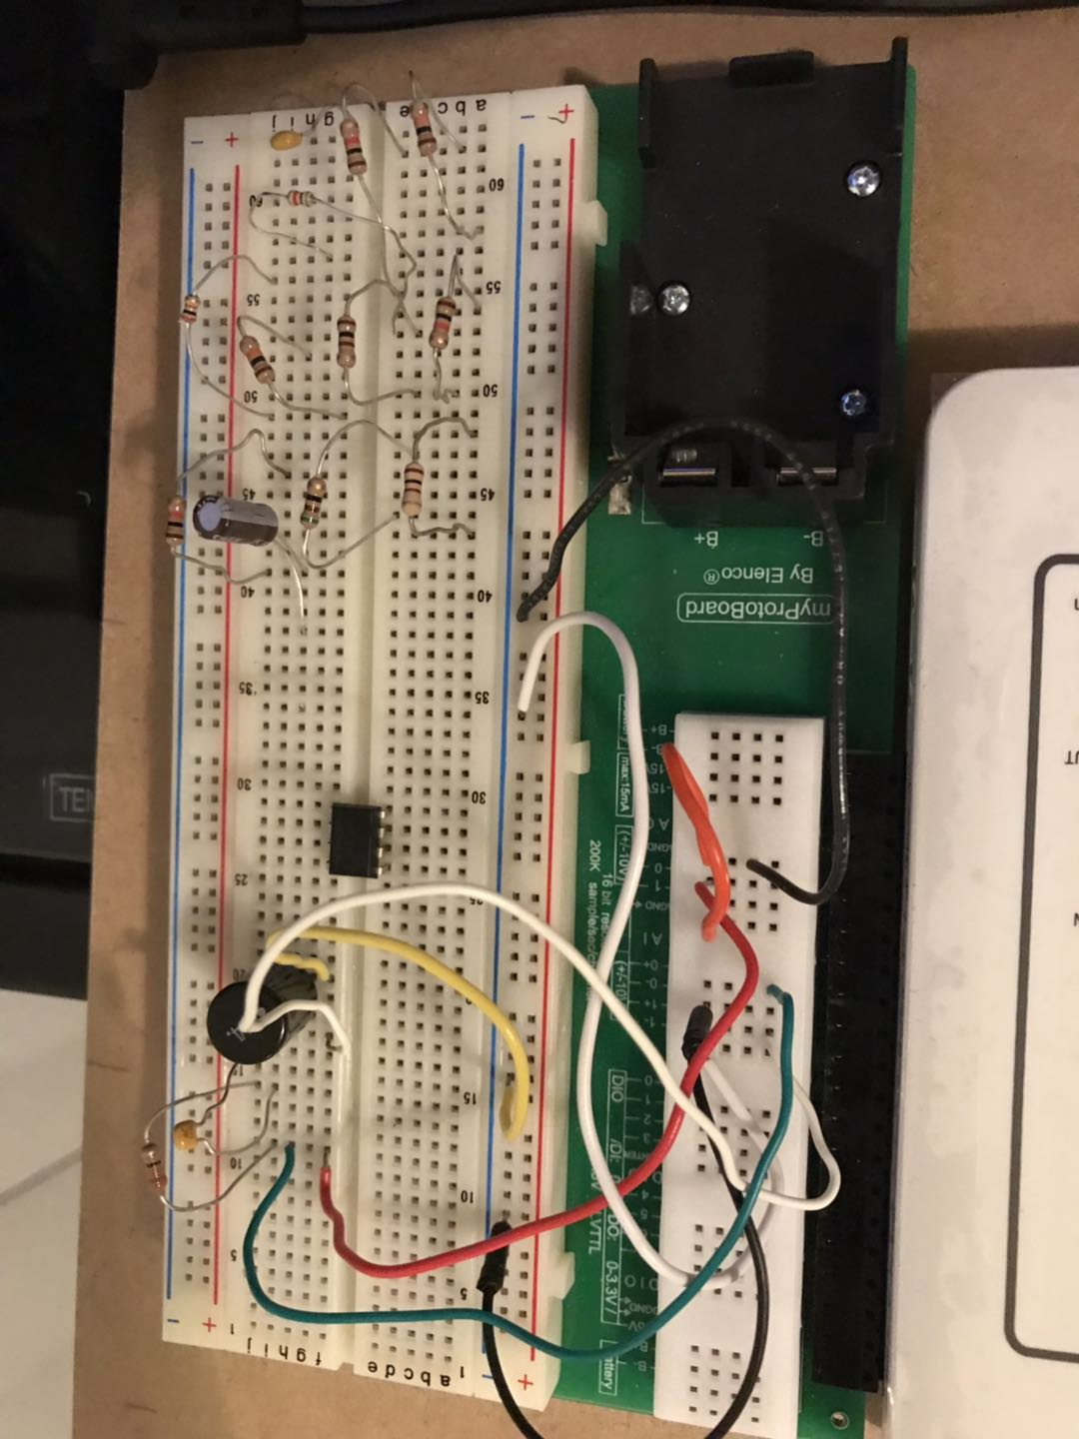Calculate the thermotical value QL and QC by using the equation 1-6, 1-7. Compare it with experimental value and find the percent error.

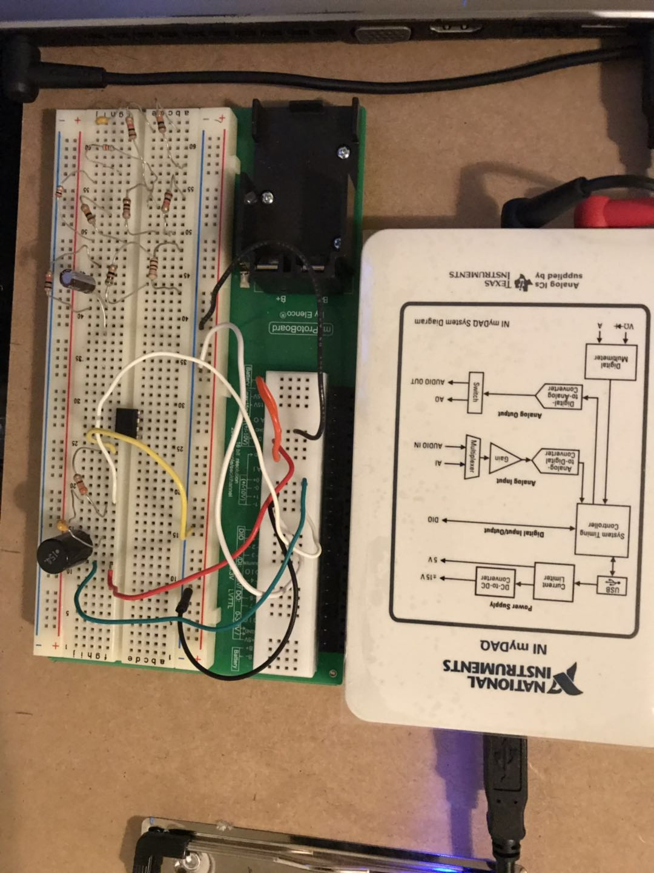

**Data:**

|  |  |  |  |  |
| --- | --- | --- | --- | --- |
|  | **Inductor** | **RL** | **Capacitor** | **Resistor** |
| Measured value | 150mH | 249Ω | 100nF | 325Ω |

1. 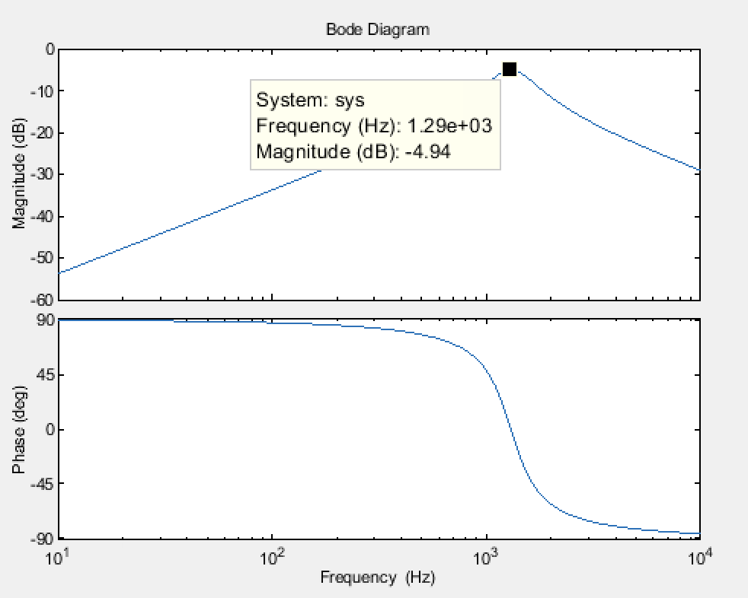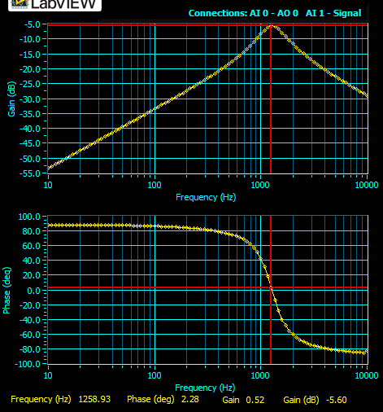**Voltage across the resistor**
2. 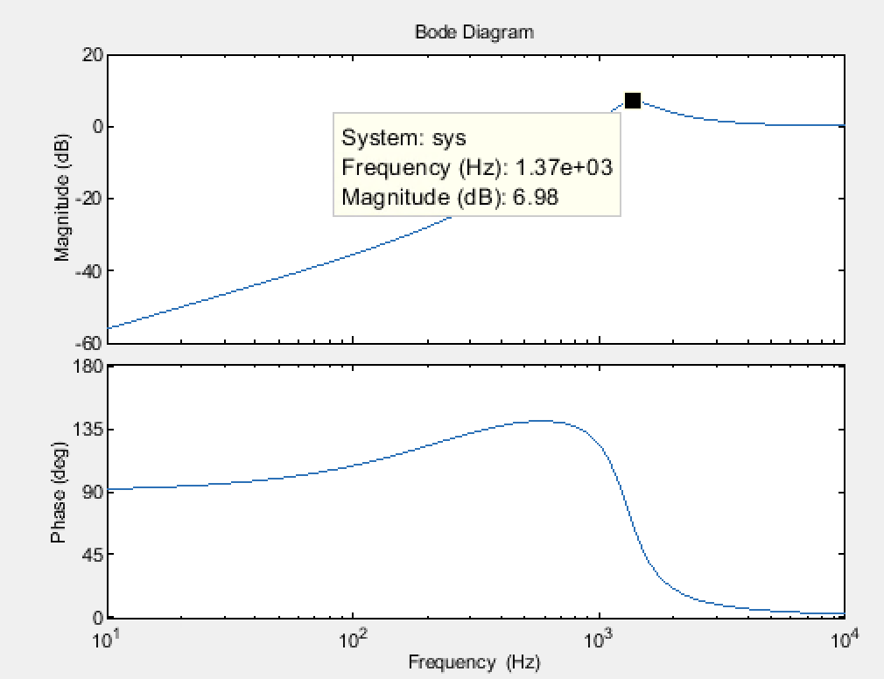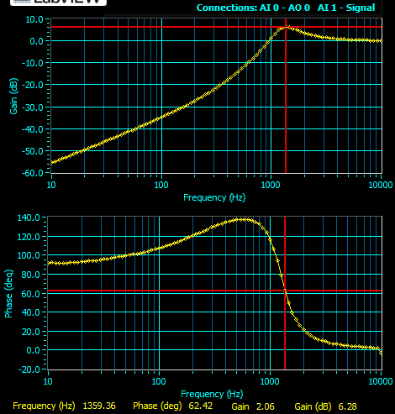**Voltage across the inductor**
3. 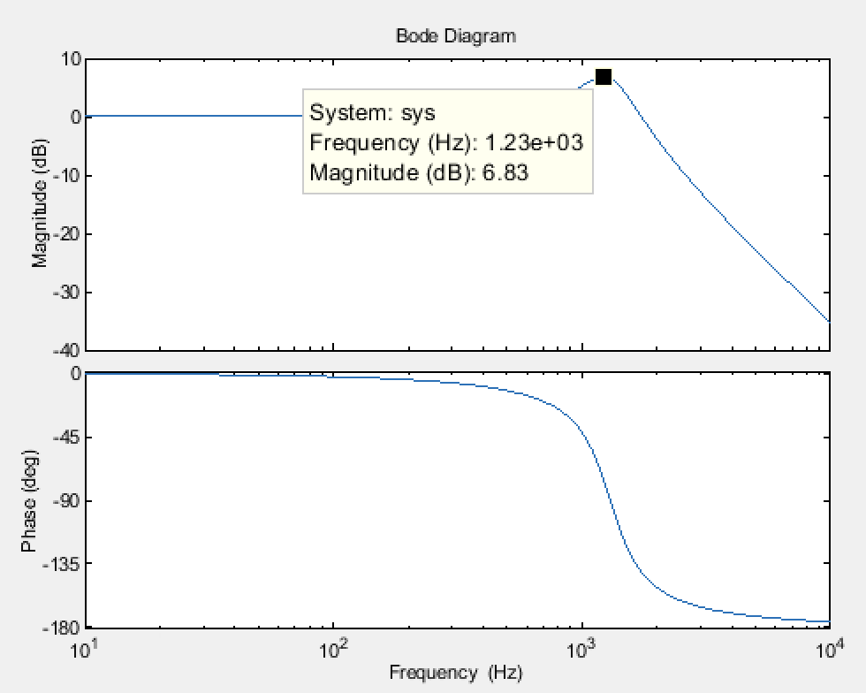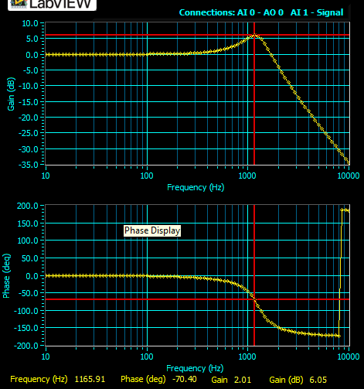**Voltage across the capacitor**

**Data Analysis:**

|  |  |  |  |  |  |  |
| --- | --- | --- | --- | --- | --- | --- |
| **Output** | **Experimental**  **Resonant frequency (Hz)** | **Theoretical**  **Resonant frequency (Hz)** | **Percent error%** | **Experimental**  **Q factor** | **Theoretical**  **Q factor** | **Percent error%** |
| **Resistor (325Ω)** | 1258.93 | 1299.50 | 3.12% | 1.77 | 2.13 | 16.9% |
| **Inductor(150mH)** | 1359.36 | 1322.999 | 2.75% | 1.27 | 2.13 | 40.38% |
| **Capacitor (100hF)** | 1165.91 | 1276.42 | 8.66% | 1.73 | 2.13 | 18.78% |

The bandwidth from VR, those data is from the myDAQ bode plot log. Repeat the same thing for VL, VC to get their bandwidth.

Freq (Hz) Gain (dB) Phase (deg)

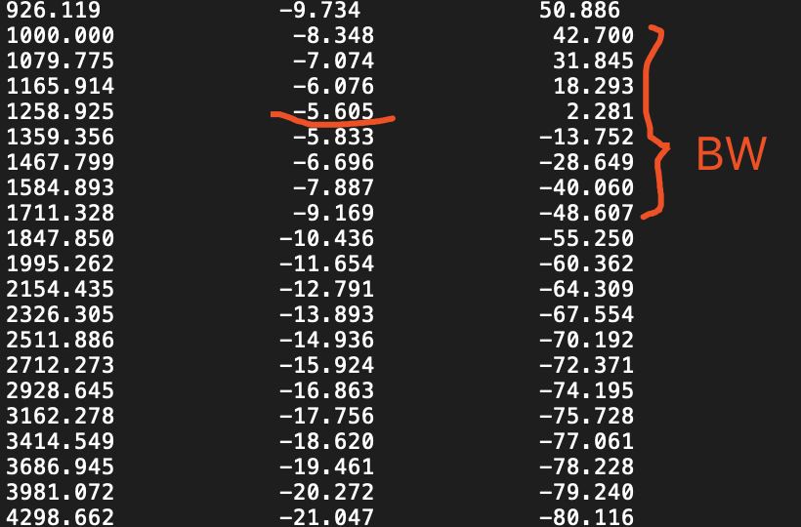

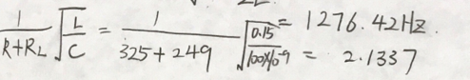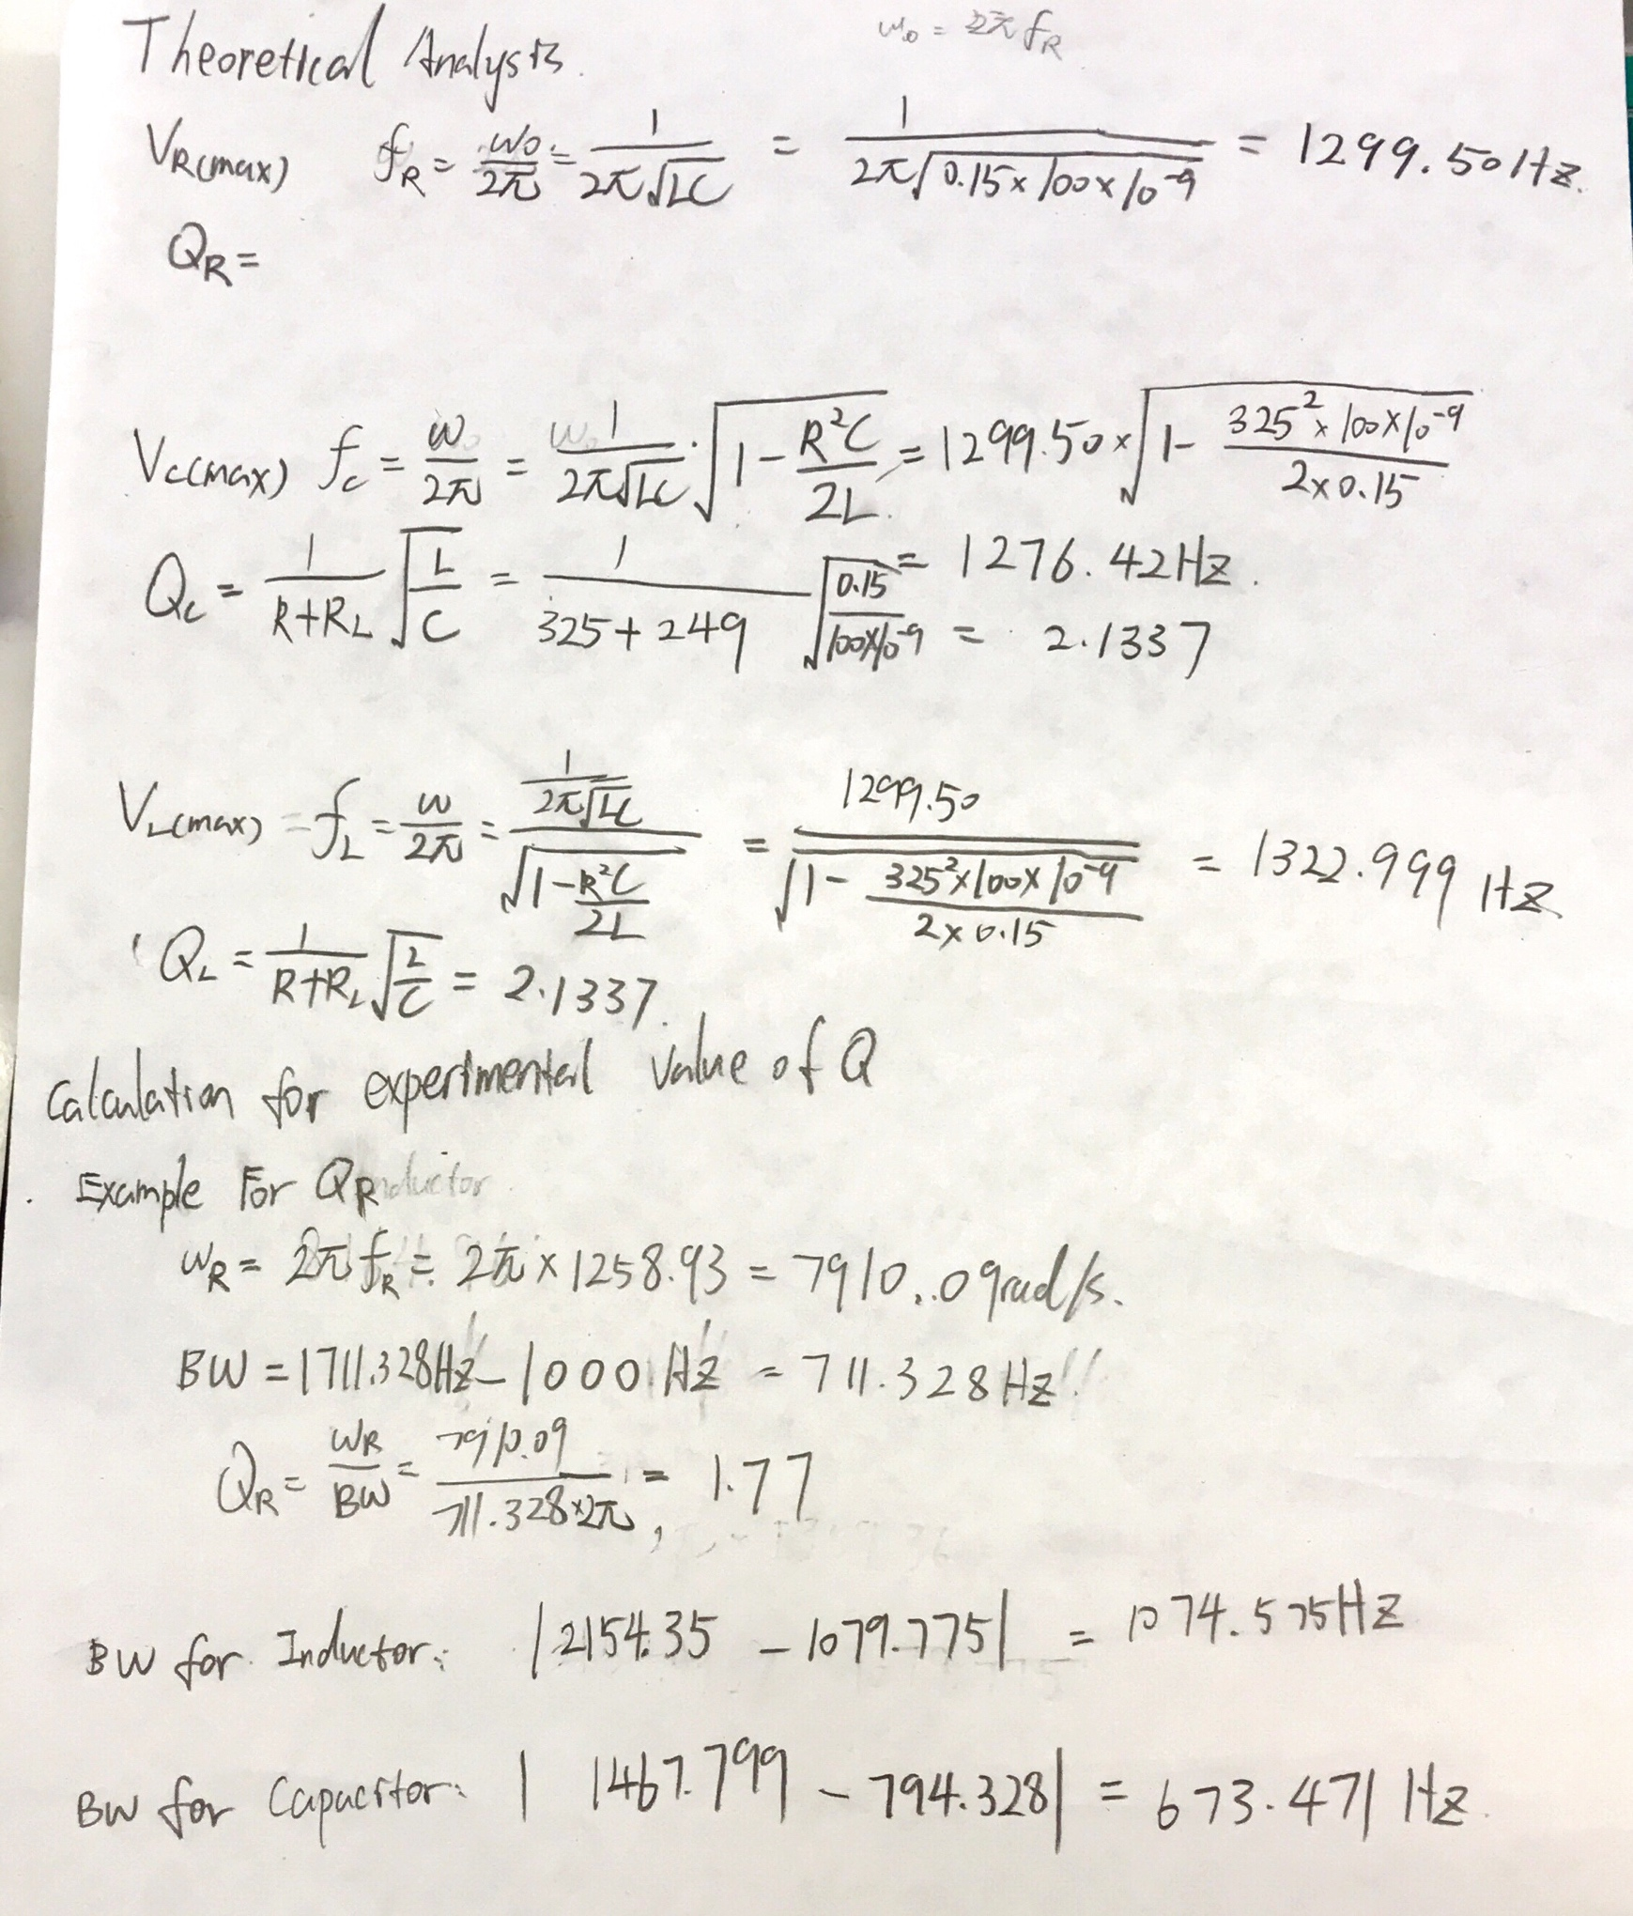

**Discussion:**

The percent error of resonant frequency is less than 10%. They are closed to the theoretical resonant frequency. However, the percent error of quality factor is very large especially the from VInductor Bode plot which is about 40% error. When we count down -3dB from the peak in the magnitude bode plot, it can produce a huge difference between the theoretical and experimental value for the resonant frequency. In addition, the myDAQ has limitation to measure the value when the frequency is high or small. It’s difficult to find accurate value of bandwidth. Therefore, the percent error of Quality factor can be large due to vary effects. Moreover, the bode plots for each component are matched with the theoretical bode plots from the MATLAB. From the resistor bode plots, it shows that it’s a bandpass filter circuit. It makes sense because at low frequency, the capacitor acts as open circuit. At the high frequency, the inductor acts as open circuit. In the capacitor bode plot, at the low frequency, the gain (dB) is 0, At high frequency, the gain(dB) decreases significantly, which it filters high frequency. In the inductor bode plot, at high frequency, the gain(dB) is 0. At low frequency, the gain(dB) decreases significantly, which it filters low frequency.

**Discussion question:**

The equations 1-1, 1-2, and 1-3 for calculating the resonant frequency are confirmed.

The percent error for resonant frequency and Quality factor are in the data analysis.

**Part#2: Parallel Resonance Circuit**

**Objectives:**

The purpose of this part is to learn the characteristics of parallel resonance circuit. Find the value of components with the specific resonance frequency.

**Theory:**

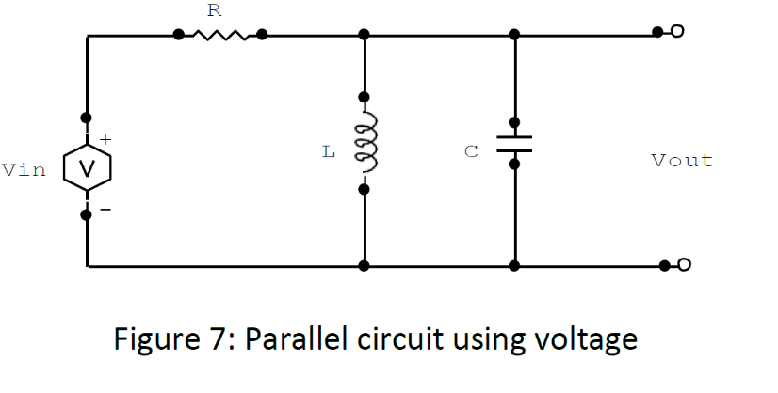

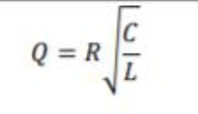

For above circuit resonance frequency is 𝜔0 = √ 1 𝐿𝐶 − (𝑅𝐿 𝐿 )2 where 𝑅𝐿 is internal resistance of the inductor. We can show that maximum of 𝑉𝑜𝑢𝑡 not appears at 𝜔 = 𝜔0.

The resonant frequency should be calculated by the equation below.

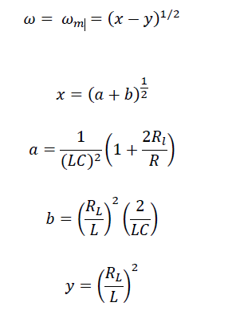

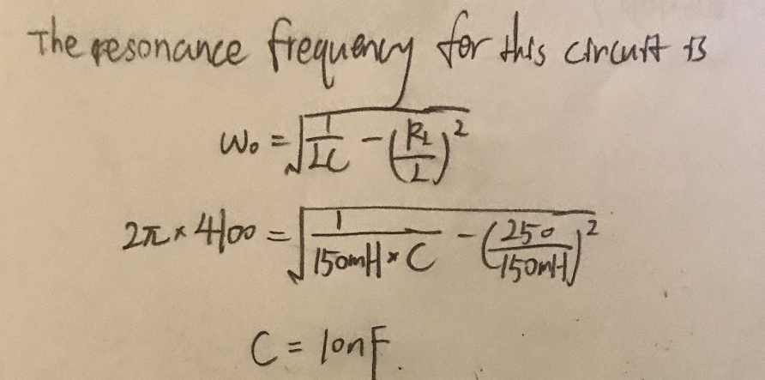

The capacitance is 10nF.

The transfer function for this circuit is:

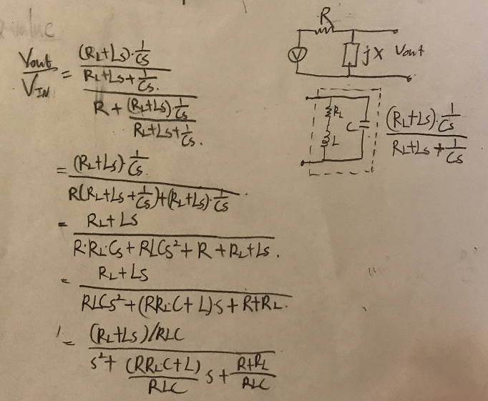

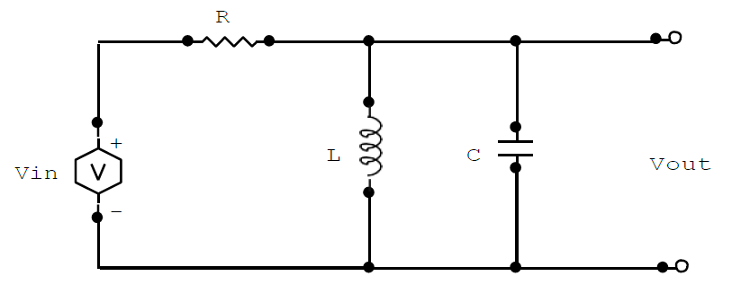**Procedure:**

1. Calculate the capacitor to make resonance frequency equal to 4.1 kHz.
2. Implement the circuit as above. L=150mH, R=1kΩ, C=10nF.
3. Using Bode analyzer to generator the Bode plot.
4. Find the resonant frequency when the magnitude bode plot for voltage is maximum. Compare it with experimental value and find the percent error.
5. 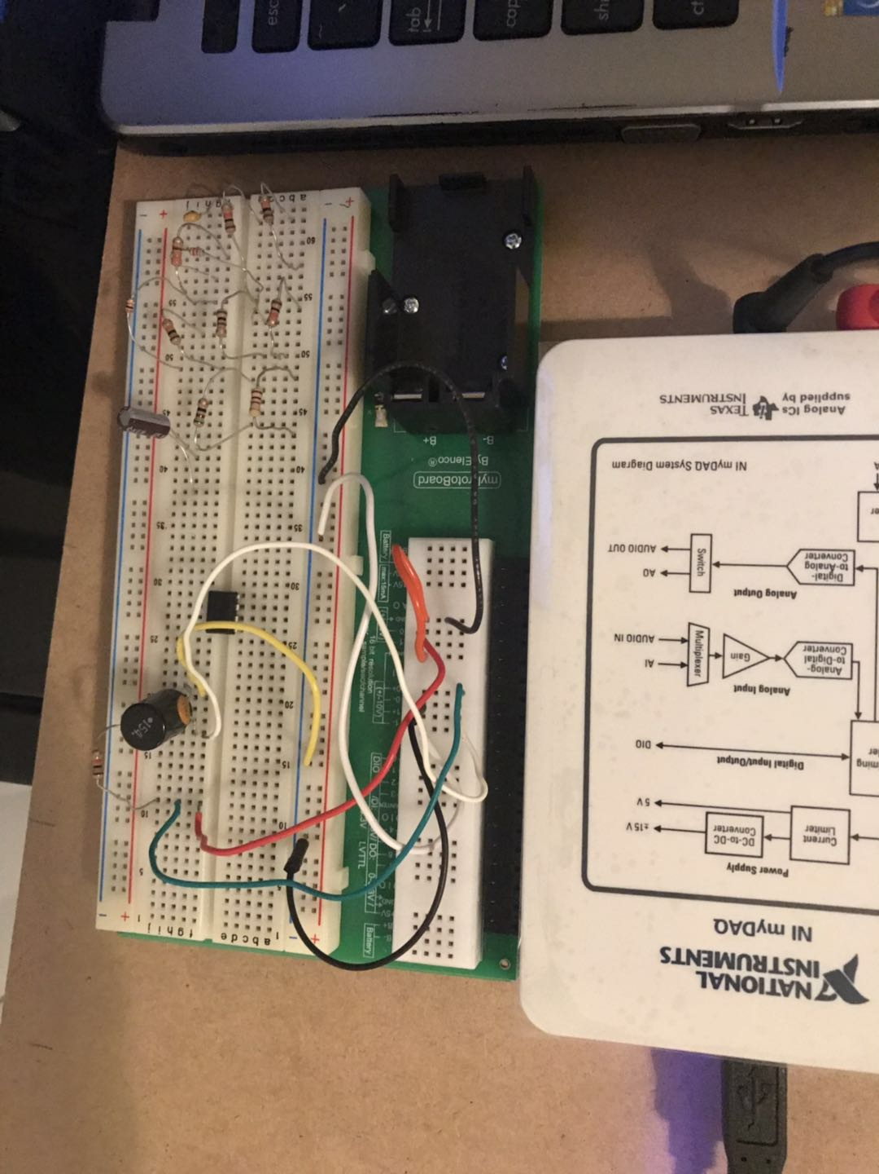From the magnitude bode plot, decrease the maximum voltage by 3-dB and find the frequency difference which is the bandwidth.
6. Find the Quality factor and compare it with theoretical value.

**Data:**

|  |  |  |  |  |
| --- | --- | --- | --- | --- |
|  | **Inductor** | **RL** | **Capacitor** | **Resistor** |
| Measured value | 150mH | 249Ω | 10nF | 988Ω |

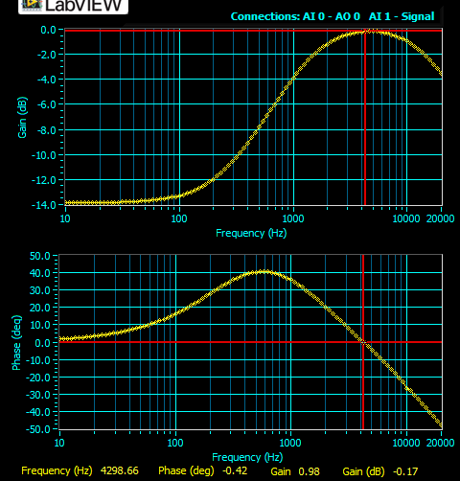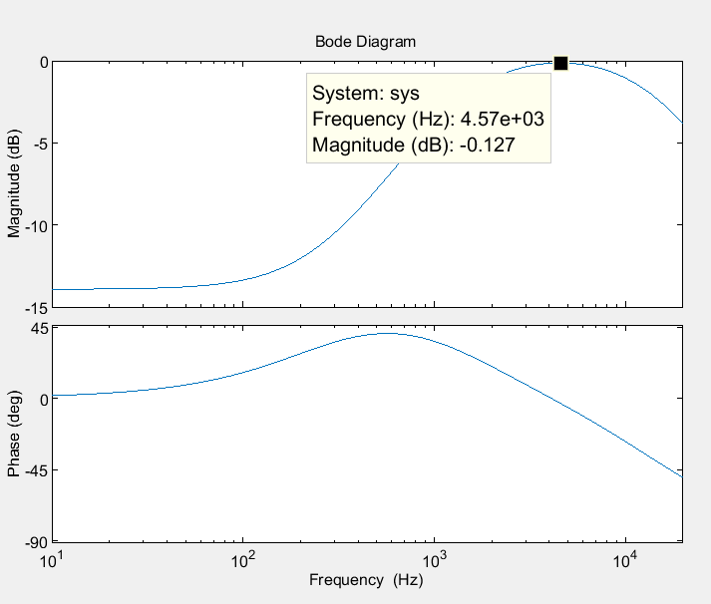Bode plot for Vout MATLAB:

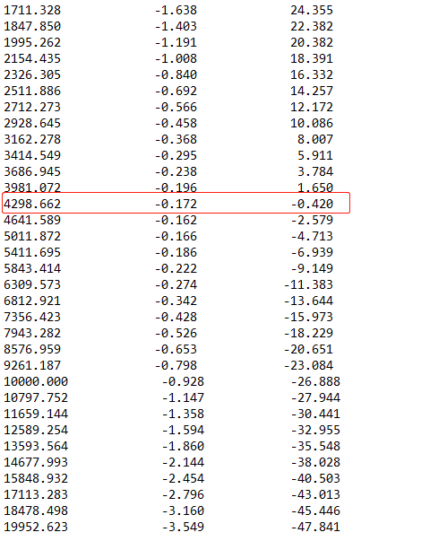Freq (Hz) Gain (dB) Phase (deg)

**Data Analysis:**

|  |  |  |  |
| --- | --- | --- | --- |
|  | **Experimental value** | **Theoretical value** | **Percent error%** |
| **Frequency at Vout maximum** | 4641.589Hz | 4549.28Hz | 2.029% |
| **Quality factor** | 0.2483 | 0.2555 | 2.82% |

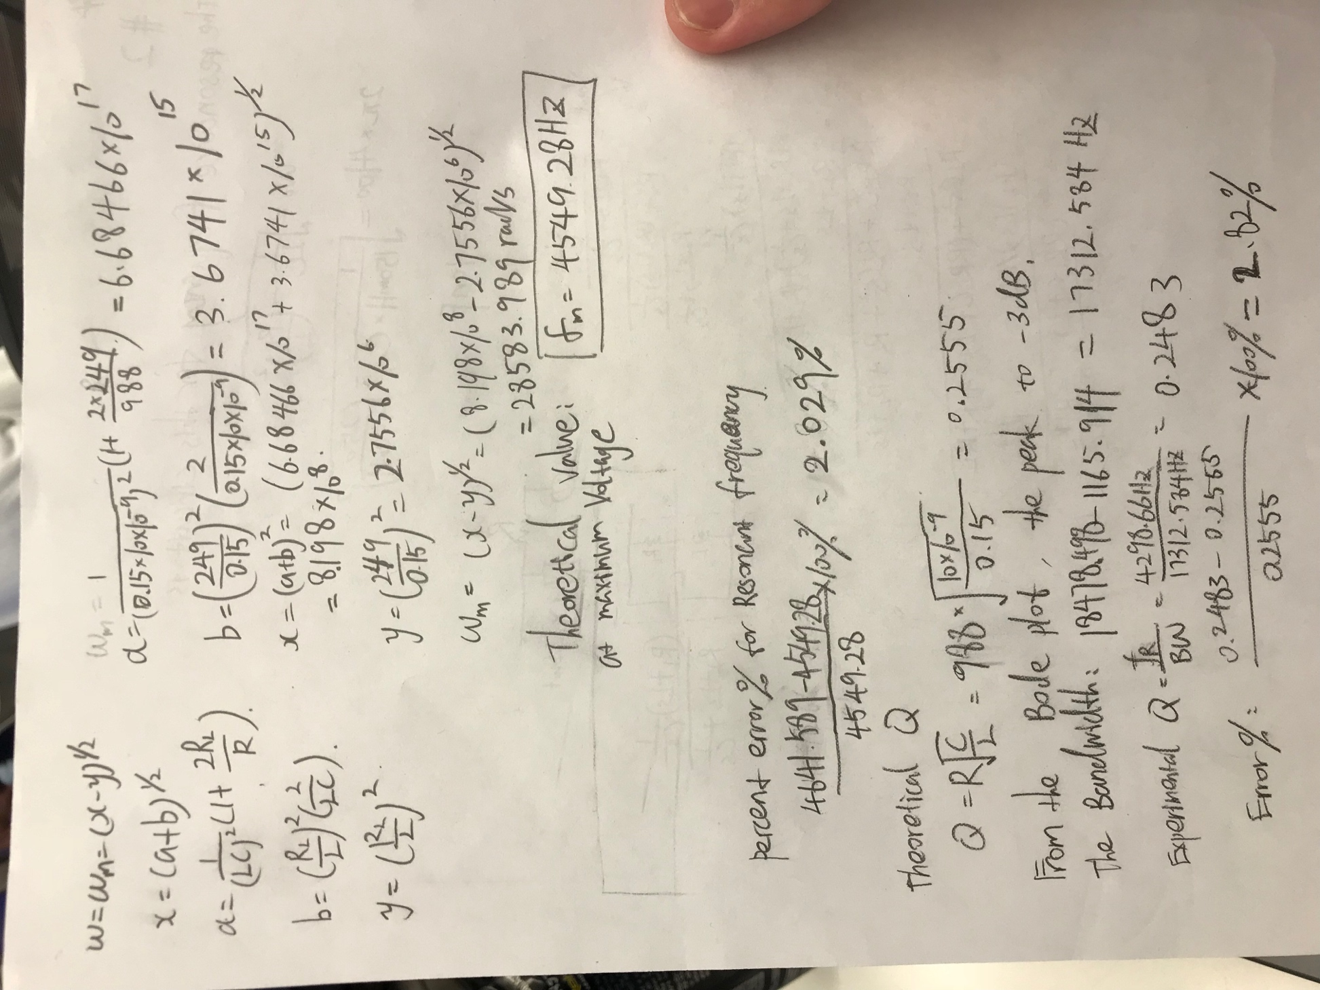

**Discussion:**

The percent error for this part is much small which is lower than 5%. The experimental bode plot is similar to the theoretical bode plot. The errors are still large even though they are smaller than part 1. The actual value of capacitor and inductor might be different from the labeled value. Also, due to the limitation of myDAQ for measuring the data, it can produce uncertainty for measurement. From the bode plot, we can see that the parallel RLC circuit is a bandpass filter. It makes sense because capacitor and inductor filter out high and low frequency signals.

**Discussion question:**

The equation for finding the Quality factor is confirmed.

The percent error for resonant frequency and Quality factor are in the data analysis.

**Conclusion:**

Throughout this experiment, the measured bode plots are matched with theoretical bode plots which are generated by the MATLAB.

We can see that a bandpass filter circuit would filter out high and low frequency. For example, when we measure the output voltage for a resistor in RLC series circuit. When the input voltage has low frequency, the capacitor acts as an open circuit. No current would cross the circuit. On the other hand, when the input voltage has high frequency, the inductor acts as open circuit, and no current crosses the circuit. At the certain frequency, it would have maximum current goes through the circuit. Therefore, we can see there is a peak at the bode plot. If we measure the output voltage for another component such as capacitor. At the high frequency, the capacitor acts as a wire, and it would not drop any voltage. Therefore, it filters out high frequency voltage.

When we calculate the Quality factor for the RLC network, we need consider the internal resistance of inductor. Otherwise, it would produce a largely different result. We can find the resonant frequency at the maximum voltage in the bode plot. However, in the part2, the resonant frequency is not the frequency at the maximum voltage. By decreasing 3dB from the peak point, we can also find the different frequency which is the bandwidth. And using the formula to calculate the quality factor.

Most of the equations are confirmed based on the experimental measurement. Most data result in a less than 10% error except the quality factor in the part 1. It’s difficult to pick a point to find the bandwidth. In addition, the quality factor itself is very small. Those many reasons produce the large percent error.